|  |  |  |  |
| --- | --- | --- | --- |
| **Group No.** | **Group Members** | | |
|  | **ID** | **Name** |
| **3** | 1. | **20-42195-1** | **LEO, NAFINUR** |
| 2. | **20-42752-1** | **HOWLADER, MD. SHAKIB** |
| 3. | **20-42794-1** | **FAHIM, SHAH NAWAJ** |
| 4. | **20-42853-1** | **RAHMAN, HASIBUR** |
| 5. | **20-42870-1** | **HASSAN, MD. ALIF** |
|  |  |  |

**Laboratory Experiment Report**

Electronic Devices Laboratory

Semester: Spring 2021-22

|  |  |  |
| --- | --- | --- |
| **Experiment No.:** 7 |  | |
| **Experiment Title:** Bipolar Junction Transistor (BJT): Study of Single Stage Transistor Common Emitter Amplifier  . |  | |
| **Date of Experiment: 20-03-2022** | | **Date of Report Submission: 17-04-2022** |

**Marking Rubrics for Laboratory Report (to be filled by Faculty)**

|  |  |  |  |  |
| --- | --- | --- | --- | --- |
| **Objectives** | **Unsatisfactory (1)** | **Good (2-3)** | **Excellent (4-5)** | **Marks** |
| **Theory** | The relevant theories are not being described properly. | Part of the relevant theories are described with proper mathematical expression and circuit diagrams (if any) | All the relevant theories are included with proper descriptions, mathematical expressions and circuit diagrams. (if any) |  |
| **Simulation circuits & Results** | Simulation circuits are not included in this report. | Partial simulation circuit results are included in this report. | All the simulation circuits are included in this report with appropriate results. |  |
| **Report Question, Discussion on Comparison between theoretical and simulation results** | Cannot reach meaningful conclusions from experimental data; Cannot summarize or compare findings to expected results | Can extract most of the accurate data. Answers to the report questions are partially correct; Summarize finding in an incomplete way | Can extract all relevant conclusion with appropriate answer to the report questions; Summarize finding in a complete & specific way |  |
| **Organization of the report** | Report is not prepared as per the instruction. | Report is organized despite of few missing sections as per the recommended structure. | Report is very well organized. |  |
| **Comments** | Assessed by (Name, Sign, and Date) | | Total (out of 20): |  |

**Experiment title:** Bipolar Junction Transistor (BJT): Study of Single Stage Transistor Common Emitter Amplifier

**Objective of this experiment:**

The objective of this experiment are,

• Trace the circuit diagram of a single stage transistor Amplifier;

• Measure the Q – Point.

• Measure the maximum signal that can be amplified with the amplifier without any distortion.

• Measure the voltage gain of the amplifier at 1KHz.

• Measure the voltage gain of the amplifier at different values of load resistance

**Theory:**

The analysis is done assuming that the signal frequency is sufficiently high. Subsequently it can be assumed that all the coupling capacitors (C1 and C2) and the bypass capacitor (CE) act as perfect short circuits. Such a frequency is said to be in the mid band of the amplifier.

The hybrid-π model and T-model can be used for the ac analysis. Those models are valid only for small signals. The general forms of these models are shown in the following figures 1 and 2.

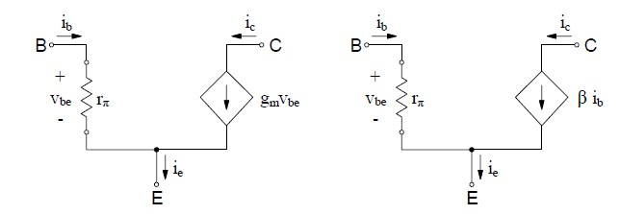

# Fig. 1: The Hybrid π-model

Where, Transconductance

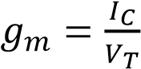 and 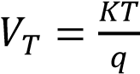

Common emitter input resistance

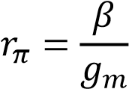

Common base input resistance

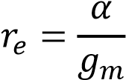

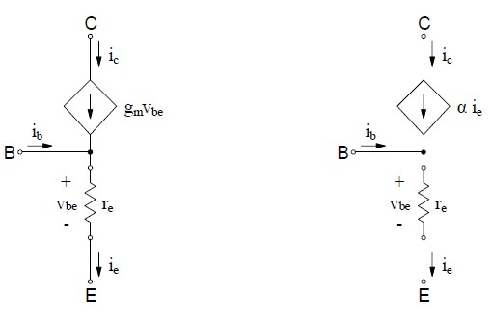

# Fig. 2: The T-model

**Apparatus:**

|  |  |  |
| --- | --- | --- |
| **No.** | **Apparatus** | **Quantity** |
| 1 | Transistor (C828) | 1 |
| 2 | 33k, 10k, 4.7k, 1k, 3.3k, 1.5k, 330Ω Resistance | 1 for each |
| 3 | Project Board | 1 |
| 4 | Cathode Ray Oscilloscope (CRO) | 1 |
| 5 | Multimeter | 1 |
| 6 | Signal Generator | 1 |
| 7 | 100μF Capacitor | 1 |
| 8 | Probes | 2 |
| 9 | Power Supply Cable | 2 |

**Simulation circuits and Results:**

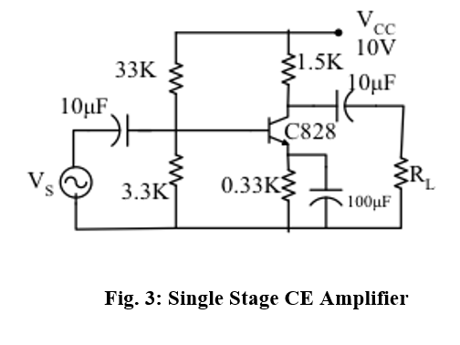

**Experimental Procedure:**

1. Measure β of the transistor with multimeter.

2. Calculate DC operating point of the transistor circuit.

3. Implement the circuit as shown in the figure.

4. Measure the operating point with the help of table: 1 and compare with your calculated value.

5. Feed ac Signal of 1 kHz at the input and observe the input and output on the CRO.

6. Increase the input signal till the output wave shape starts getting distorted. Measure this input signal. This is the maximum input signal that the amplifier can amplify without any distortion.

7. Now feed an ac signal that is less than the maximum signal handling capacity of the amplifier. Fix the input signal frequency at 1 KHz, Draw the input and output voltage wave shape and calculate gain.

**Observations:**

1. Q – Point of the amplifier.

|  |  |  |  |  |
| --- | --- | --- | --- | --- |
| **VCC** | **VC** | **VCC - VC** | **IC = (VCC-VC) / RC** | **VCE** |
| 10 | 4.97 | 5.03 | 3.35 | 2.78 |

1. Maximum signal that can be handled by the amplifier without introducing distortion =

V and Operating frequency = ……………KHz

1. Voltage Gain of the amplifier:

|  |  |  |  |
| --- | --- | --- | --- |
| **Load Resistor** | **Input voltage** | **Output Voltage** | **Gain** |
| 1K | 20 mV | 0.45 V | 22.5 |
| 4.7K | 20 mV | 0.72 V | 36 |
| 10K | 20 mV | 0.94 V | 47 |
| 100K | 20 mV | 1.2 V | 60 |

**Simulation and Measurement:**

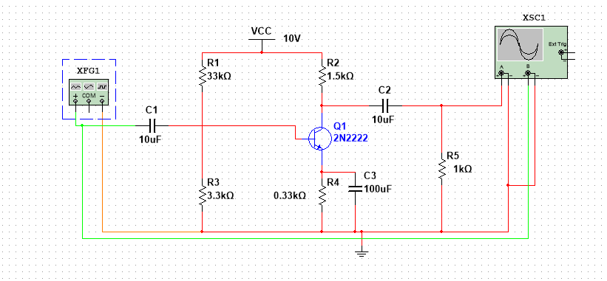

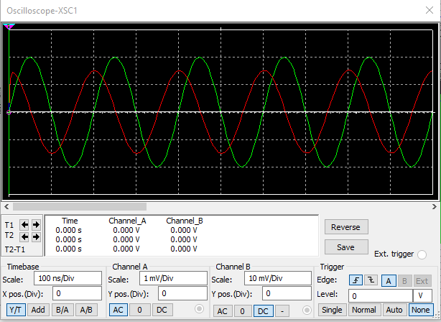

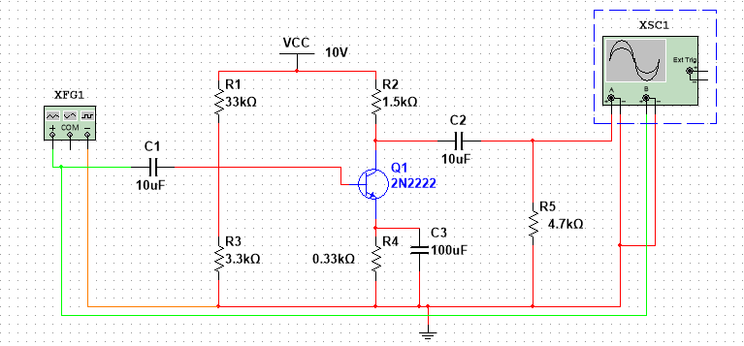

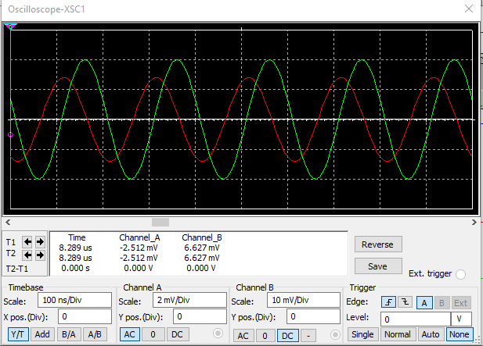

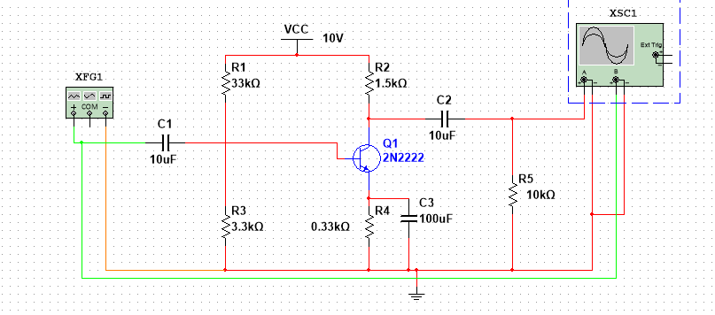

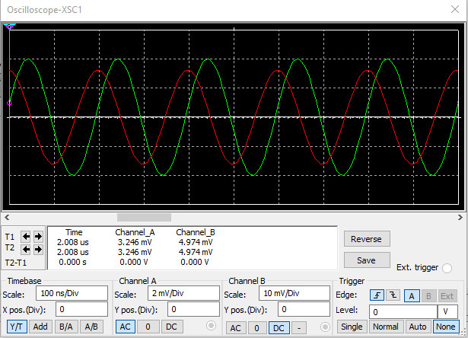

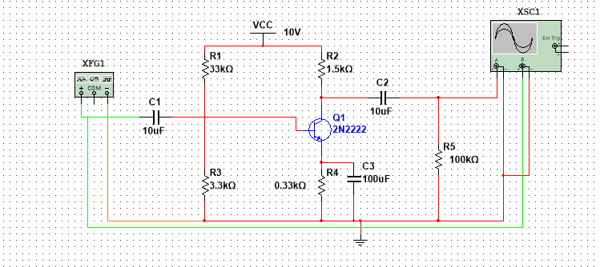

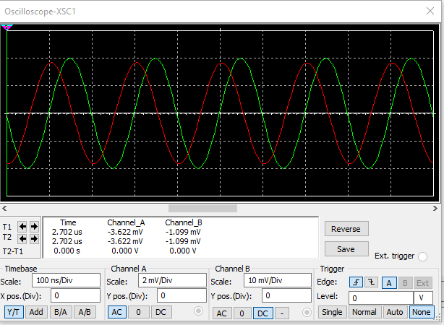

**Discussion:**

1. All the apparatus were checked before the start of the experiment. Care should be taken  
to avoid short connections. Short connections can produce heat (due to high current flow)  
which can be harmful for the components and damage the component.  
2. The experimental results were slightly different from the simulated results which could  
happen due to improper connection, contact resistance and variation of source power.  
3. The AC analysis is proper for small signal analysing.

**Conclusion:**  
In this experiment the data were interpreted and determine to the extent to which the experiment  
was successful in complying. The goal was initially set. The ways of the study was improved,  
investigated and described by observing the circuit.

**References:**

1. American International University–Bangladesh (AIUB) Electronic Devices Lab Manual.

2. A.S. Sedra, K.C. Smith, “Microelectronic Circuits,” Oxford University Press (1998).

3. J. Keown, ORCAD PSpice and Circuit Analysis, Prentice Hall Press (2001)

4. P. Horowitz, W. Hill, “The Art of Electronics,” Cambridge University Press (1989).